

Protein Productions

Vikings Division

San Jose State University

ISE 140 Operations and Control

Professor Anil Kumar

December 11, 2017

Vanessa Bravo

Kathryn Jetter

Bhairavi Shah

Hari Hara Sudhan Venkateswaran

Table of Contents

Executive Summary 2

1.0 Introduction 3

1.1 Background 3

1.2 Problem Statement 3

1.3 Objective 3

2.0 Methods and Procedures 3

2.1 Forecasting 3

2.1.1 Forecasting Methods Research 4

2.1.2 Product 1 4

2.1.3 Product 2 4

2.1.4 Product 3 4

2.1.5 Product 4 4

2.1.6 Product 5 5

2.2 Planning 5

2.3 Materials Requirements Planning 5

2.4 Capacity Planning 5

2.5 Simulation and Scheduling 5

3.0 Results 6

3.1 Forecasting 6

3.2 Planning 6

3.3 MRP 6

3.4 Capacity Planning 7

3.5 Scheduling 7

4.0 Conclusion and Recommendations 7

4.1 Conclusions 7

4.2 Recommendations 7

4.3 Weekly Journal 7

5.0 References 8

6.0 Appendix 9

6.1 Appendix A – Forecasting 9

6.2 Appendix B – Aggregate Planning 14

6.3 Appendix C – MRP Records 19

6.4 Appendix D – MPS 22

6.5 Appendix E – Capacity Planning 22

6.6 Appendix F – Scheduling 27

6.7 Appendix G – Cost Tables 29

6.8 Appendix H – List of Tables and Figures 31

Executive Summary

This report is in response to the Vikings Division, a subsidiary of AK Enterprise. Experiencing a decline in sales due to new competitors, they hoped to reassess their company’s process. The report elaborates on the developed strategy by our company to improve their efficiency in production and sales.

Our company was given data from the last ten periods from each of their five products. Beginning with forecasting based off collected data, seasonality and trends were observed to determine a method to find the next five periods. Each of the products was evaluated independently from the other. Shown by graphing the historical data, each has its own trend. The method performed to compute the next forecasts must have a MAD tolerance of ten or less. Two outside forecasts abetted in confirming two of the five forecast values.

After confirming the forecasts our company developed a chase plan, capacity plan and scheduling simulation using ProModel. This encompassed the necessary data to calculate the needed machines and cost of production. The chase plan is the principal factor that ensures efficiency throughout the rest of production. The ProModel simulation showed that the Shortest Processing Time (SPT) technique for scheduling provided the lowest cycle time. Our recommendation therefore is to schedule product production based on SPT.

It is recommended that Vikings Division continually track their sale history and monitor the trends. They should keep tracking and making changes in their forecasts, production plan and capacity planning. Assembled in this report is an updated plan that shall increase sales and decrease any backorders.

Keywords: MRP (Materials Requirement Planning), MPS (Master Production Schedule), BOM (Bill of Materials), MAD (Mean Absolute Deviation), WIP (Work in process), SPT (Shortest Processing Time), LPT (Longest Processing Time), FIFO (First in First Out), ARIMA (Autoregressive Moving Average)

# 1.0 Introduction

## 1.1 Background

The Vikings Division, a subsidiary of AK Enterprise produces a variety of nutritional products. Their main focus is producing Product 1,2,3,4 and 5 and distributing them directly to distributors and wholesalers. While their patent was valid, four years ago, there were no competitors. At the time, no other companies were interested in nutritional products. However, ever since their patent expired, they noticed various companies making similar products due to increasing demands for those product types.

## 1.2 Problem Statement

Over the years, the company has faced a loss in profit leading them to do an analysis of their products. They found that they had increasing backorders. Furthermore, it was discovered that there was poor utilization of machines, production of wrong product quantities for each product type, and inappropriate lot sizes were run that led to long production cycle times and WIP. The company was being run inefficiently creating loss aside from the growing competitors.

## 1.3 Objective

From the production data collected and run through various procedures, an optimal strategy will be obtained for the company for the production of their products. Along with the strategy, a total cost analysis was carried out. Each of the products will be evaluated separately.

# 2.0 Methods and Procedures

The methods and procedures applied to each product consists but are not limited to forecasting, production plans and scheduling which are further explained below.

## 2.1 Forecasting

To begin, the data collected was plotted for an overall visual of the five products past demand. Then, the first ten periods collected was observed and tested with various forecasting methods. The results were compared with the next ten data points to validate the accuracy of the forecast. The method with the most accurate result was chosen to predict the next five periods; this was confirmed by comparing the predicted and given forecast as well as ensuring that the MAD tolerance was less than ten. The next five calculated forecast values were used throughout the rest of the project to create a plan.

Figure 1 - Graphical representation of Historical Demand of Product 1,2,3,4 and 5

### 2.1.1 Forecasting Methods Research

Aside from the forecast methods applied, two other forecasting methods were considered. **ARIMA1** and **Theta Model2** were other forecasting models researched. Within the journal found, the study compares various economic and time series models predicting retail sales. It was found that the use of statistical models such as ARIMA, “forecasts single variables” better than the others. Furthermore, when applied ARIMA to product 5, calculated forecasts were often similar or slightly better than normal economic models, ARIMA calculated more accurate values than exponential smoothing. The Theta Model method consists on modifying the local curvature of the time-series through a coefficient named “Theta” which is applied directly to the second differences of the data. By creating this series, the resulting keeps the mean and slope from the original data as the same but changes the curvatures. The main characteristic of this method is to improve and approximate the long-term behaviour of the data and features, all depending on the Theta coefficient. This method could be applied to product 3 or 5 since both output graphs have a varying historical demand with no clear pattern.

### 2.1.2 Product 1

A forecast model was predicted from the trend shown in Figure 1. It is clear Exponential Smoothing was the method that followed this product. This model was chosen because the demand values show no clear pattern, so the forecasting method would have to provide a conservative estimate of expected demand. After testing this method with the previous forecasts, a MAD tolerance was calculated to be 9.54, also shown in Table.

### 2.1.3 Product 2

When looking at the historical data also shown in Figure 1, it is observed that there is a Seasonal pattern without trend. There was a long upward then downward trend. Using this method, it was evaluated by using the previous data. The forecast model was a good fit given that the MAD tolerance computed was 2.68. The data was tested with trend; however, the MAD tolerance was much higher. Also, there was no constant upward trend and so seasonal without trend was the best fit.

### 2.1.4 Product 3

For product three, it was predicted to be Seasonal with Trend. Although similar to product two, there were more cycles. As displayed in Figure 1, there is a clearer trend that flows up and down. The trend is more consistent with the seasons appearing to total four. Overall, the graph of the product was increasing. Because trend was used, ɑ, β and 𝛾 were modified to keep the MAD tolerance below ten; the values for each of the variables were 0.2. This is an acceptable value, therefore, seasonal with trend forecast model was the best fit.

### 2.1.5 Product 4

The forecast model that was used based on the trend shown in Figure 1 was Linear Regression. The graph displays a straight and upward trend. Trend could be applied as a second level of constancy; however, it was not necessary. The first MAD tolerance consisting of .89 was low enough ensuring that there was no need to add a trend. It was found that the regression equation was y= 15.33+3.19x. This was checked with Minitab and the ANOVA output.

### 2.1.6 Product 5

The forecast model that was used based on the trend shown in Figure 1 was Exponential Smoothing. Product five was more difficult to trace. There could be a slight seasonality or trend. This model was chosen because the demand values show no clear pattern and so our forecasting method would have to provide a conservative estimate of expected future demand. Another method was used to analyse this product. ARIMA was used to confirm the forecast values using exponential smoothing were accurate and to assure the MAD is less than ten. The MAD calculated to be 9.357 for Exponential Smoothing and 8.7 with ARIMA.

## 2.2 Planning

After developing the following five forecasts, an aggregate plan was developed. Both a level and chase production strategy were created for each product to correlate with each of the five periods. This would form the foundation to production, inventory, backorders and needed workforce. Then, the total cost of both plans would be calculated and observed. Depending on which method was more efficient and cost effective, it will be used for the forecasted demand. The assumption made here is that there are 480 manufacturing minutes in a day, 5 manufacturing days in a week and 52 working weeks in a year. The cost analysis calculated covers the production quantity, ending inventory, backorders, needed workers and any required under time.

## 2.3 Materials Requirements Planning

An MRP was established to lay out an efficient manufacturing process. A forecasted demand will be formed by the MRP record based off the BOM. Following, an MPS was developed for the sub-products required to make the final products.

## 2.4 Capacity Planning

Taking the data from the MRP, a capacity plan will be created for both the main and sub products. This will indicate how many machines will be required for the production to fulfill the demand; it will take into consideration the down time. Furthermore, it will calculate the total cost for the optimal strategy.

A rough-cut analysis was performed based off the capacity bills given. Additionally, the previous MPS, cost breakdown, routings, machines and specified times were needed to compute the plan. Individually, the products were analyzed and the needed time to meet demand was computed for each machine in each of the five periods. Once all of the sub-products were determined, the totals were added together by machine and week. Following, the downtime was evaluated with the estimated failures and repair time. Next a summation of each week was run including the processing time, downtime and time for repairs. Last, the needed time required was divided by the allotted time giving the number of machines the station during that week requires.

## 2.5 Simulation and Scheduling

The simulation done using ProModel takes the MRP planned order releases as arrivals and the capacity of each station from the capacity planning’s requirement depending on the number of machines for each station. The processing times are used as inputs for the processing table. The setup time and down time are to be used in the locations tab for each station. One of the constraints faced, was the runt time. Based on the data collected from Capacity planning, the run time should be 40 hours or less. However, the optimal run time reached in the simulation created was 43.5 hours using SPT scheduling.

Scheduling utilizes the queuing functions at the locations, and since the goal is to find the optimum sequencing method, the scheduling techniques tested in the model are FIFO, SPT and LPT. Each scheduling technique is tested for its cycle time and the one with the best cycle time is selected for production of the sub-products.

Three scheduling techniques were considered for determining the lowest cycle time. The techniques are FIFO, SPT and LPT. The scheduling techniques are used in the queueing functions in the Locations in the ProModel. The production demands for the 21st week is considered for the finding the best scheduling technique. The MPS values are considered to be the lot size for each sub product.

The simulation input parameters are taken from the MPS and Capacity planning for the sub products. The arrivals to the stations are the MPS values from 21st week. For SPT and LPT, priority values are given to the sub products based on the total processing time required for each.

# 

# 3.0 Results

## 

## 3.1 Forecasting

*Table 1 - Summary of Forecasting Models used*

|  |  |  |
| --- | --- | --- |
| Product Type | Forecasting Models | MAD |
| Product 1 | Exponential Smoothing | 9.54 |
| Product 2 | Seasonal without Trend | 2.675 |
| Product 3 | Seasonal with Trend | 7.8 |
| Product 4 | Linear Regression | 0.89 |
| Product 5 | Exponential Smoothing | 9.357 |

Other results are mentioned in Table A‑1 and Appendix A.

## 3.2 Planning

Table 2 - Aggregate Planning and the methods chosen

|  |  |  |  |
| --- | --- | --- | --- |
| Product Type | Level Plan ($) | Chase Plan ($) | Plan Chosen |
| Product 1[1] | 177520 | 177520 | Level |
| Product 2 | 156824 | 229920 | Level |
| Product 3 | 156813 | 171880 | Level |
| Product 4 | 208380 | 232260 | Level |
| Product 5 | 222474 | 222440 | Chase |

The individual cost plans for each product are further broken down in Appendix B.

## 3.3 MRP

The planned order releases were calculated for the main products 1,2,3,4 and 5 based on which the gross requirements followed by the planned order releases for the sub-products 1,2,3 and 4 were calculated. The data used for this was taken from the BOM of each product. These values are mentioned in Appendix C and the final MPS values are in Appendix D.

## 3.4 Capacity Planning

The final results of the sub-products can be seen in Appendix E.

The cost of utilizing the machines is $2,736,000 and the under-time cost is $70,374.76 as mentioned in Appendix G.

## 3.5 Scheduling

Based on the % Utilization and the run time required for each station, shown in Appendix F, **SPT** was chosen as the optimal scheduling technique.

# 4.0 Conclusion and Recommendations

## 4.1 Conclusions

The calculations performed should help the company standardize its production operations to be able to effectively meet customer requirements and reduce its operating costs.

* The overall cost of the project is $ 3,983,163.76 (Appendix G)
* Level plan was calculated to be the best method applicable to use for product 1,2,3,4 and Chase plan for product 5
* The best scheduling technique simulated was found to be SPT (Shortest Processing Time) based on the throughput and % utilization.
* There is no forecasting method that can be applied to all products. It has to be chosen based on historical trend of each product.

## 4.2 Recommendations

Our company recommends that an annual analysis of the products is updated. This is to ensure of any changes in trend or seasonality. Further calculations can be made to recompute the workers needed, machines and products.

## 4.3 Weekly Journal

As this project was carried out, it is important to keep track of its development. This aided in the efficiency of our own company and documented the process taken to solve Vikings Division’s problem. When a task was brainstormed, laid out or completed, the information was compiled together in the attached journal. Additionally, this journal kept track of scheduled meetings and individual progress.

# 5.0 References

1 Bechter, D. M., & Rutner, J. L. (1978, March). Forecasting With Statistical Models and a Case Study of Retail Sales. Retrieved September, 2017, from https://www.kansascityfed.org/NaVOZ/OKWMZ/nfVLQ/OfjaZ/PUBLICAT/ECONREV/EconRevArchive/1978/1q78bech-2.pdf

2Assimakopoulos, V. & Nikolopoulos, N. (2000). The theta model: a decomposition approach to forecasting. *International Journal of Forecasting.* 16 (4).

# 6.0 Appendix

## 6.1 Appendix A – Forecasting

Table A‑1 - Forecasted Values Summary

|  |  |  |  |  |  |
| --- | --- | --- | --- | --- | --- |
| Product | Week 21 | Week 22 | Week 23 | Week 24 | Week 25 |
| Product 1 | 144 | 143 | 150 | 149 | 146 |
| Product 2 | 178 | 200 | 215 | 205 | 170 |
| Product 3 | 121 | 97 | 84 | 69 | 127 |
| Product 4 | 83 | 86 | 89 | 92 | 96 |
| Product 5 | 48 | 50 | 45 | 50 | 46 |

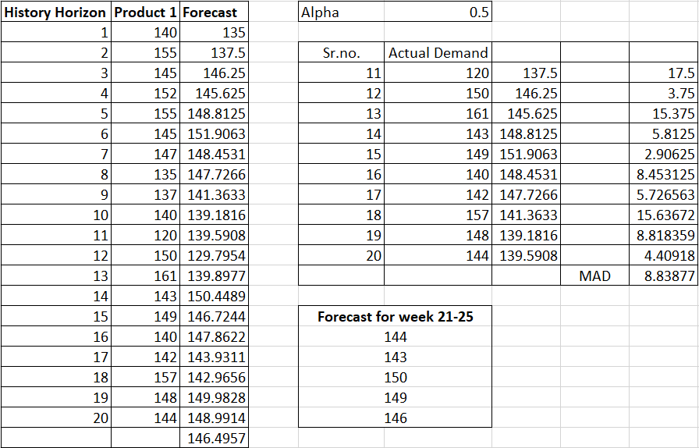

Figure A‑1 - Product 1 – Forecasted Calculations

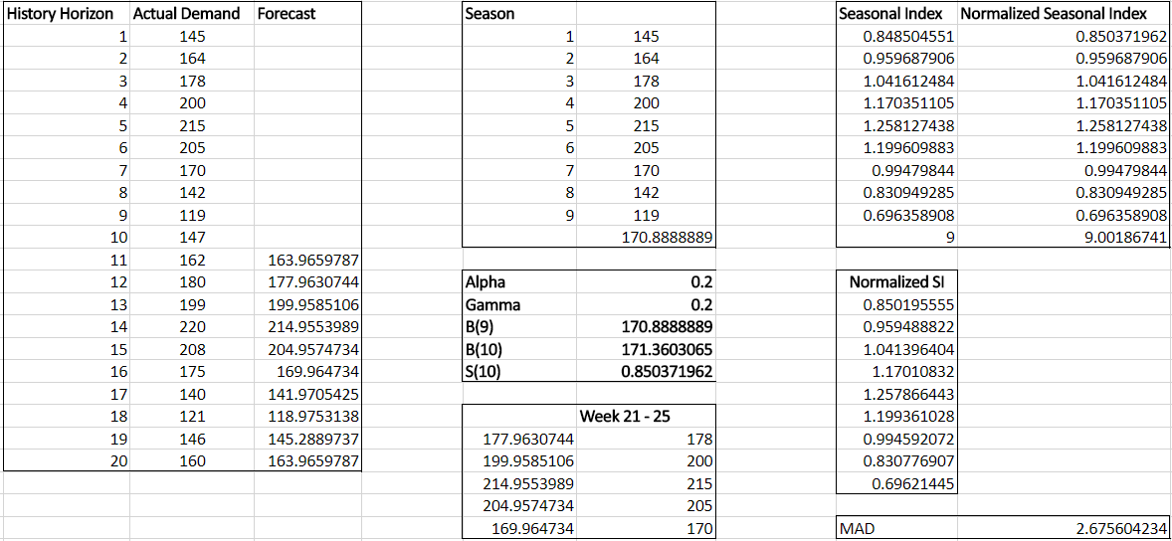

Figure A‑2 - Product 2– Forecasted Calculations

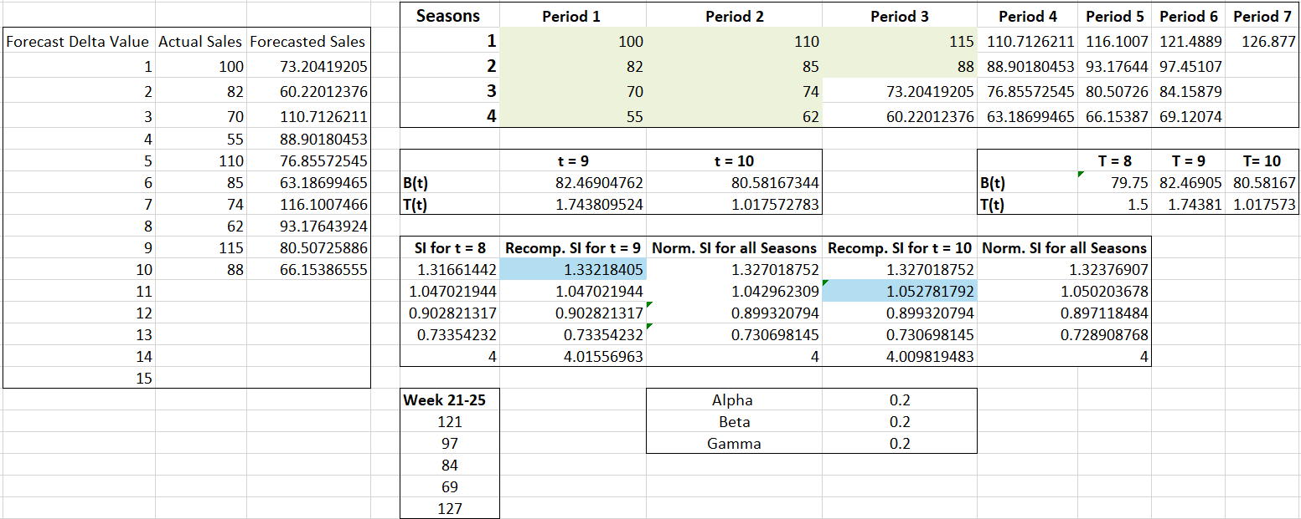

Figure A‑3 - Product 3 – Forecasted Calculations

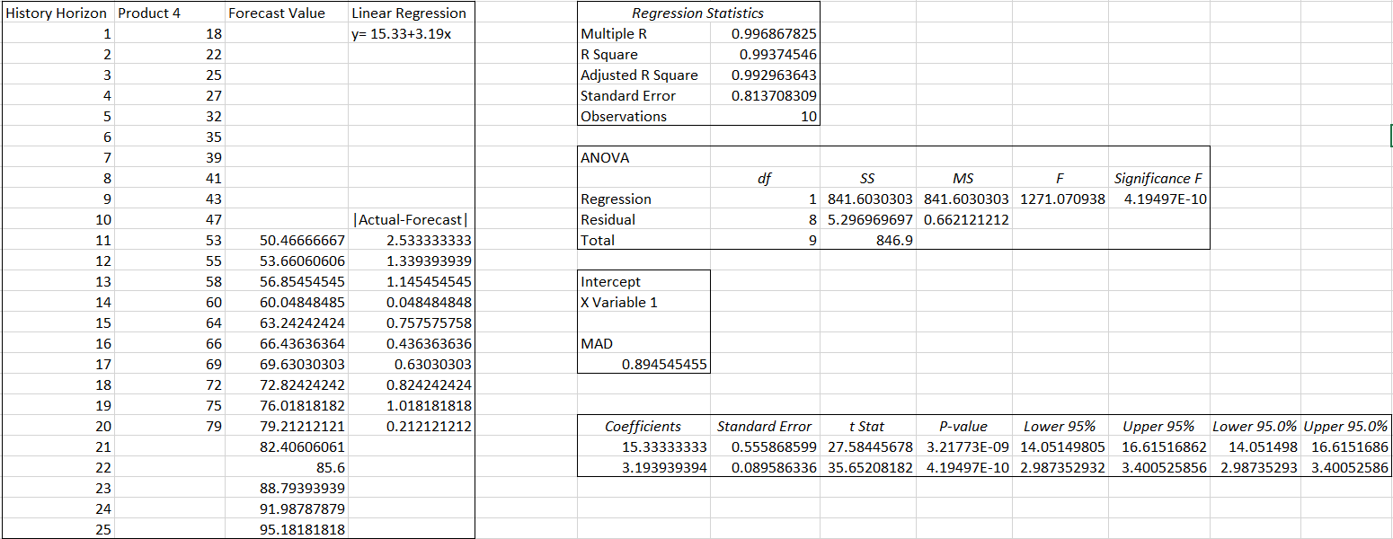

Figure A‑4 - Product 4 – Forecasted Calculations

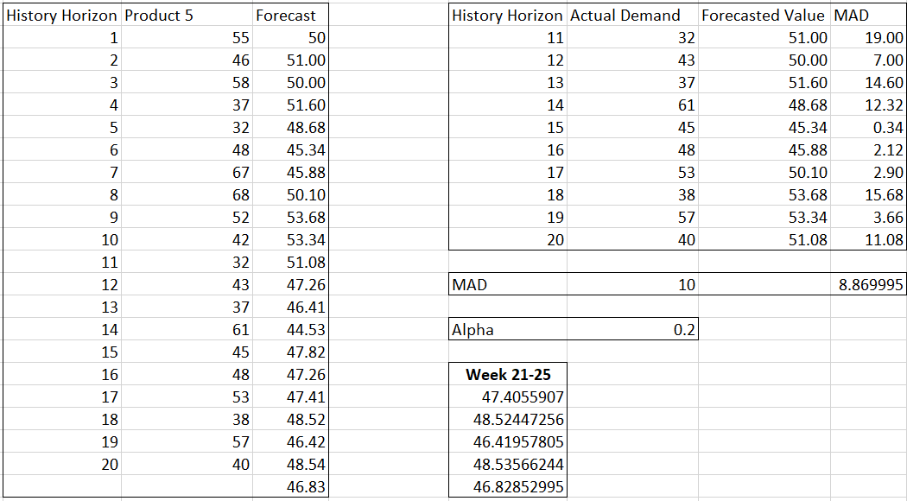

Figure A‑5 - Product 5 – Forecasted Calculations

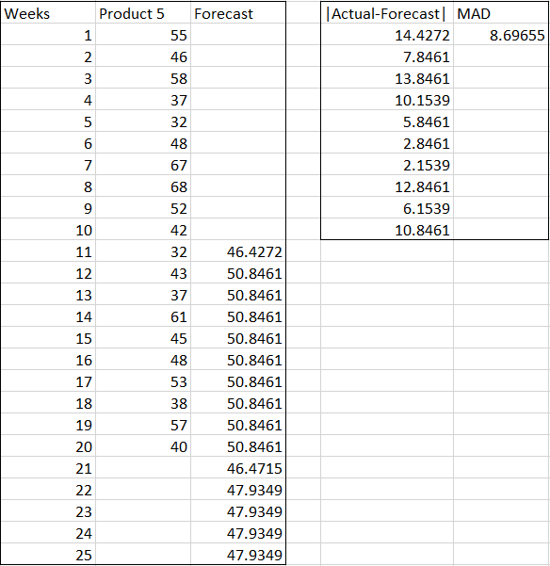

Figure A‑6 - Product 5 – Forecasted Calculations with Arima



Figure A‑7 - Minitab Output

## 6.2 Appendix B – Aggregate Planning

Table B‑1 - Product 1 (Level Plan)

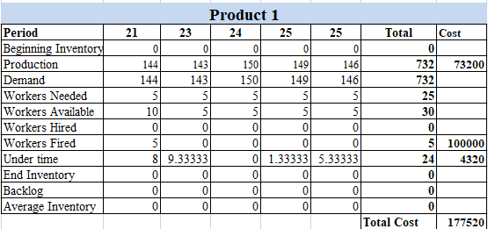

Table B ‑2 - Product 1 (Chase Plan)

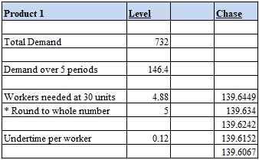

Table B ‑3 - Computations

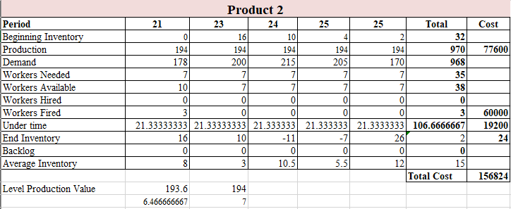

Table B ‑4 - Product 2 (Level Plan)

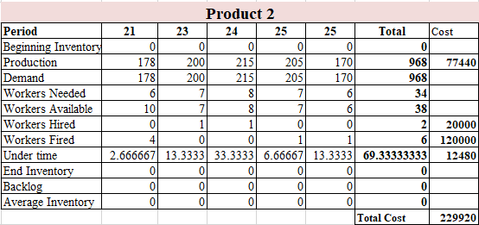

Table B ‑5 - Product 2 (Chase Plan)

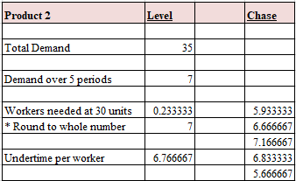

Table B ‑6 - Computations

Table B‑7 - Product 3 (Level Plan)

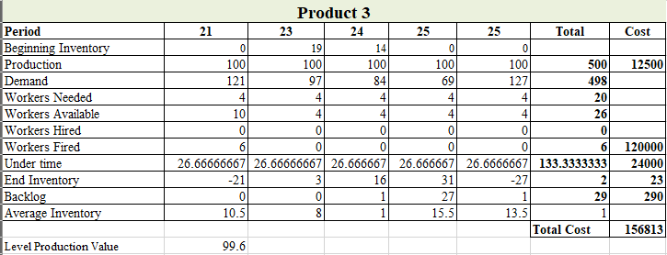

Table B ‑8 - Product 3 (Chase Plan)

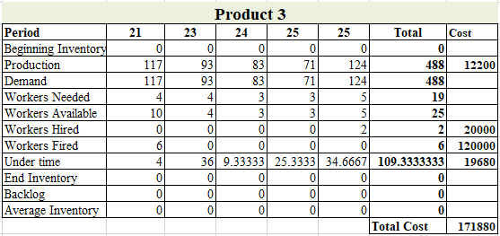

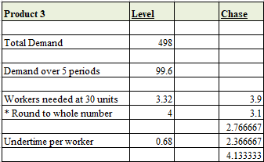

Table B ‑9 - Computations

Table B‑10 - Product 4 (Level Plan)

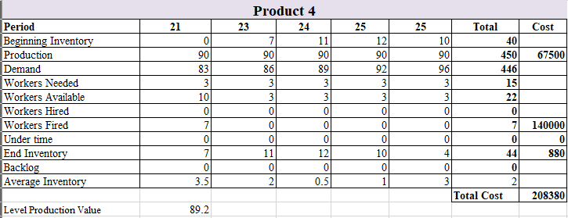

Table B ‑11 - Product 4 (Chase Plan)

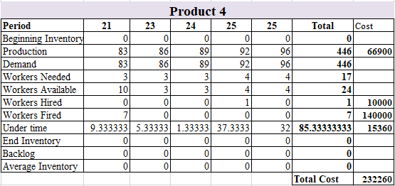

Table B ‑12 - Computations

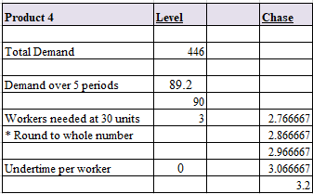

Table B ‑13 - Product 5 (Level Plan)

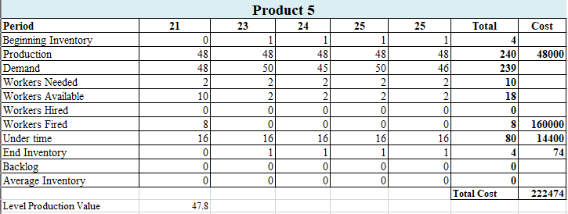

Table B ‑14 - Product 5 (Chase Plan)

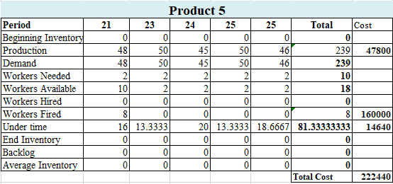

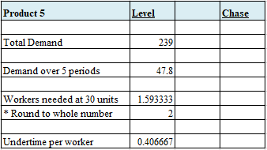

Table B ‑15 - Computations

## 6.3 Appendix C – MRP Records

Table C‑1 - Product 1 MRP

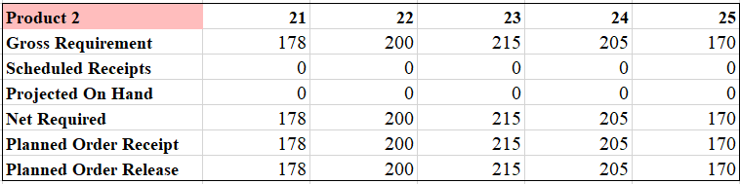

Table C‑2 - Product 2 MRP

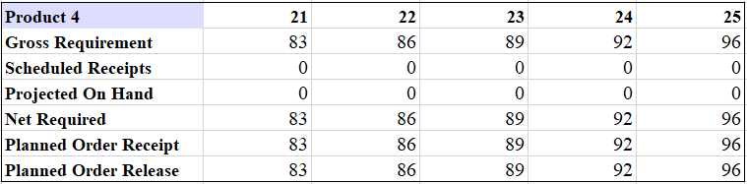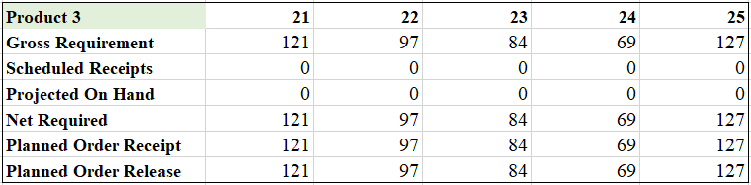

Table C‑4 - Product 4 MRP

Table C‑3 - Product 3 MRP

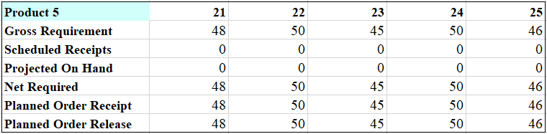

Table C‑6 - Sub-Product 1 MRP

Table C‑5 - Product 5 MRP

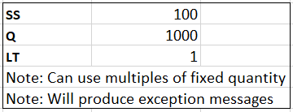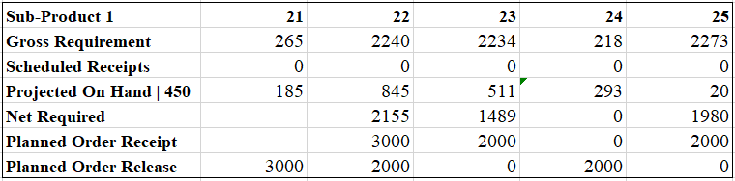

Table C‑7 - Sub-Product 2 MRP

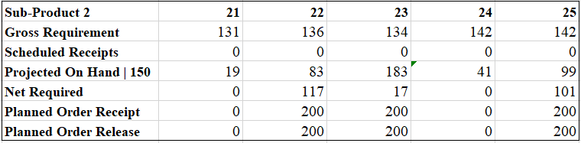

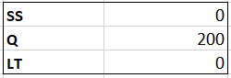

Table C‑8 - Sub-Product 3 MRP

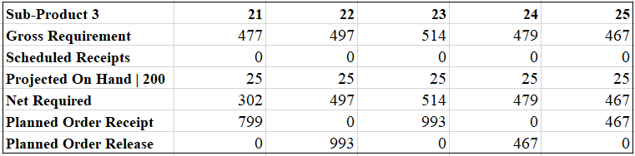

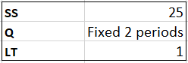

Table C‑9 - Sub-Product 3 MRP

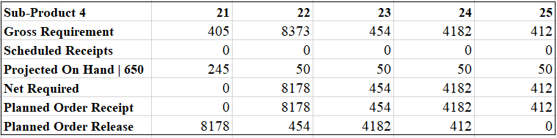

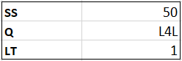

## 

## 6.4 Appendix D – MPS

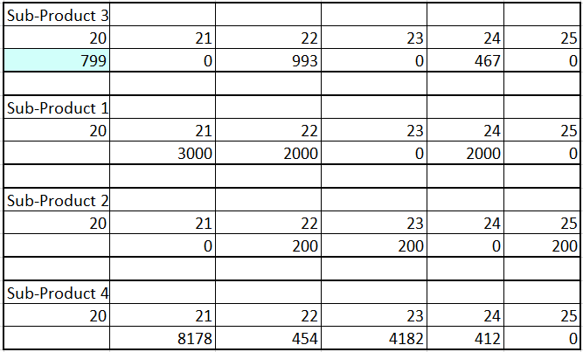

Table D‑1 - Sub-Product MPS

## 6.5 Appendix E – Capacity Planning

Table E‑1 - Sub-Product 1 Capacity Plan

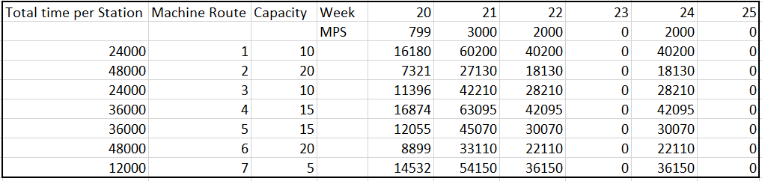

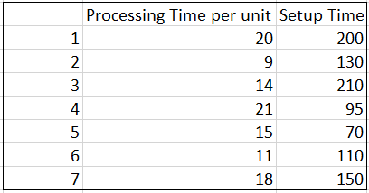

Table E‑2 - Sub-Product 2 Capacity Plan

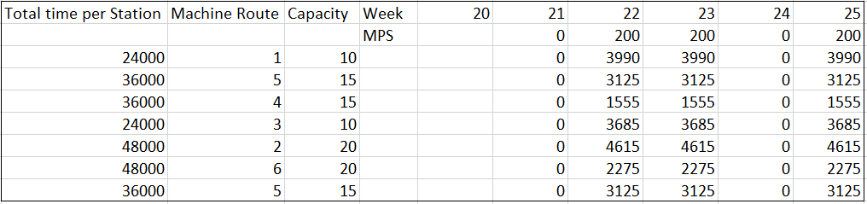

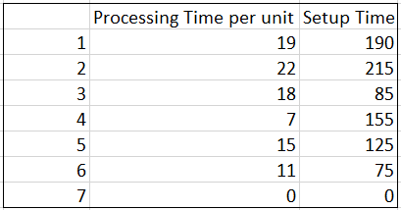

Table E‑3 - Sub-Product 3 Capacity Plan

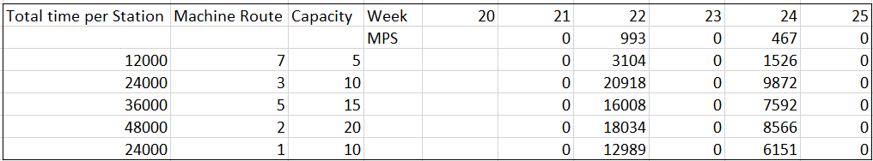

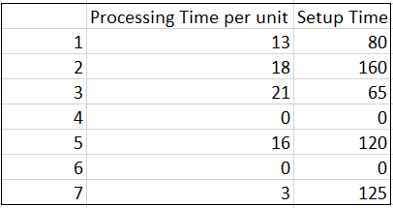

Table E‑4 - Sub-Product 4 Capacity Plan

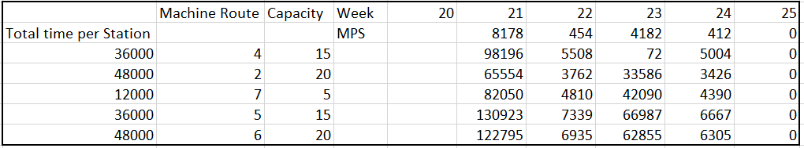

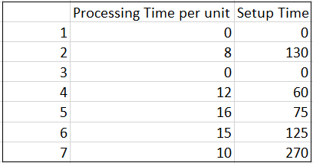

Table E‑5 - Machine Hour Totals per week per Machine

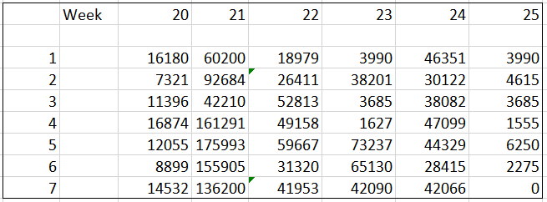

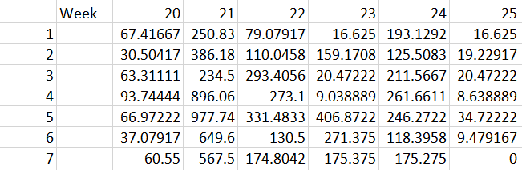Table E‑6 - Calculating Number of Downtimes for each Machine per Week

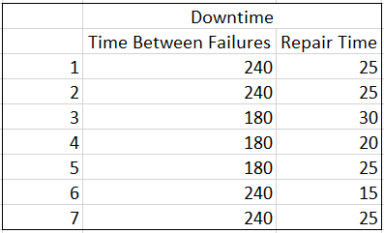

Table E‑7 - Calculating Repair Time (Dependent on Number of failures)

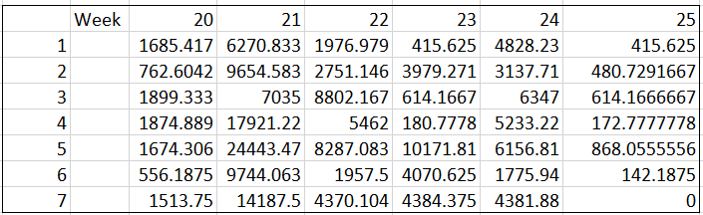

Table E‑8 - Total Time Needed per station in each week

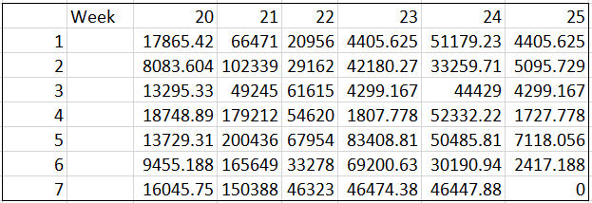

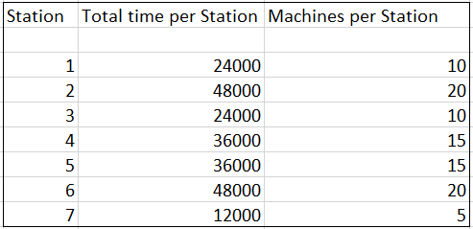

Table E‑9 - Capacity of Machines

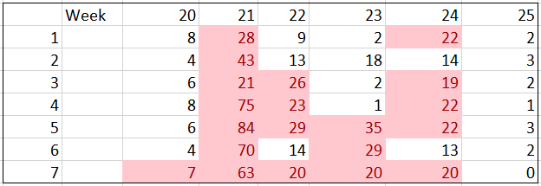

## 6.6 Appendix F – Scheduling

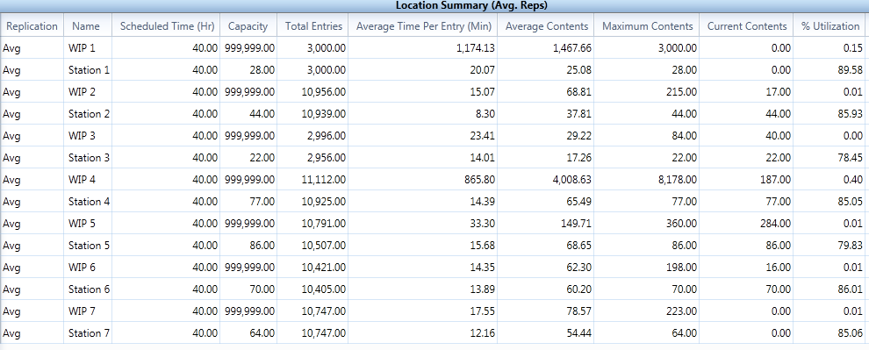Table F‑1 - LPT Location Summary

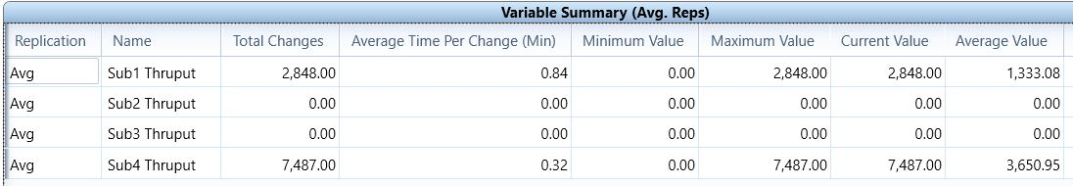Table F‑2 - LPT Throughput Summary

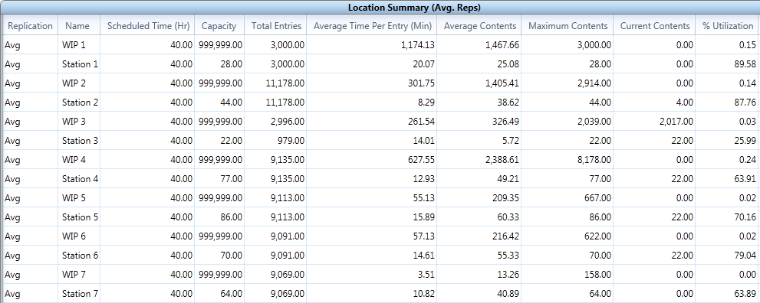Table F‑3 - SPT Location Summary

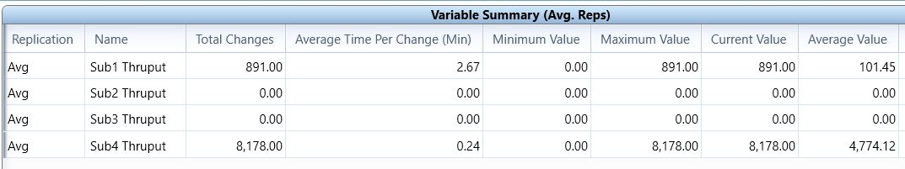Table F‑4 - SPT Throughput Summary

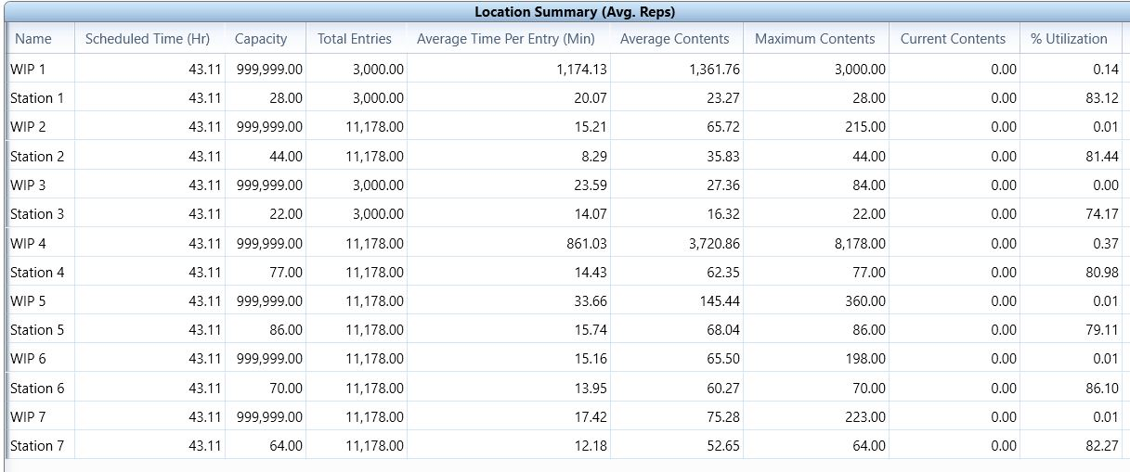Table F‑5 - FIFO Location Summary

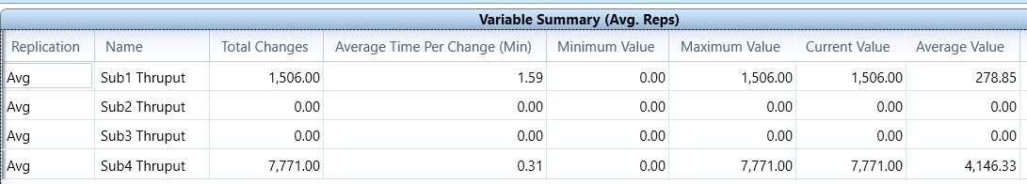Table F‑6 - FIFO Throughput Summary

## 6.7 Appendix G – Cost Tables

Table G‑1 - Production and Aggregate Costs

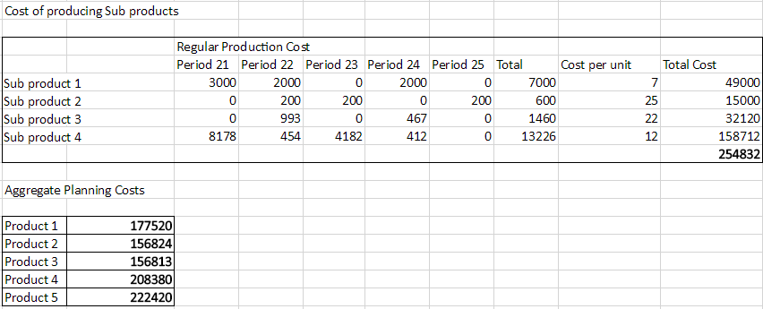

Table G‑2 - Rate of Machines

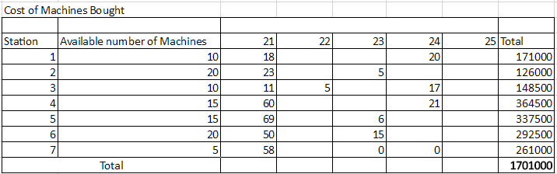

Table G‑3 - Cost of Machines Bought

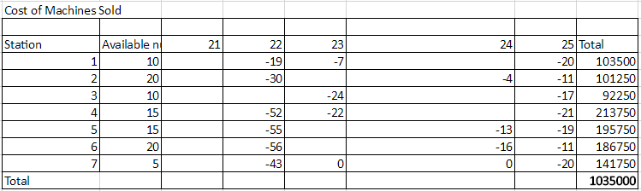

Table G‑4 - Cost of Machines Sold

Table G‑5 - Under-time Cost

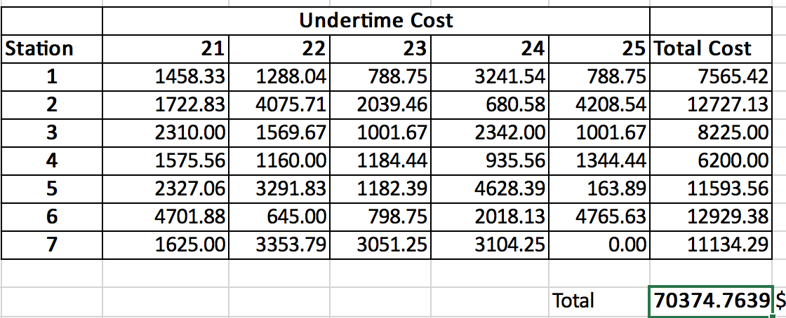

## 6.8 Appendix H – List of Tables and Figures

List of Tables

*Table 1 - Summary of Forecasting Models used* 6

Table A‑1 - Forecasted Values Summary 9

Table B‑1 - Product 1 (Level Plan) 14

Table B ‑2 - Product 1 (Chase Plan) 14

Table B ‑3 - Computations 14

Table B ‑4 - Product 2 (Level Plan) 15

Table B ‑5 - Product 2 (Chase Plan) 15

Table B ‑6 - Computations 15

Table B‑7 - Product 3 (Level Plan) 16

Table B ‑8 - Product 3 (Chase Plan) 16

Table B ‑9 - Computations 16

Table B‑10 - Product 4 (Level Plan) 17

Table B ‑11 - Product 4 (Chase Plan) 17

Table B ‑12 - Computations 17

Table B ‑13 - Product 5 (Level Plan) 18

Table B ‑14 - Product 5 (Chase Plan) 18

Table B ‑15 - Computations 18

Table C‑1 - Product 1 MRP 19

Table C‑2 - Product 2 MRP 19

Table C‑4 - Product 4 MRP 19

Table C‑3 - Product 3 MRP 19

Table C‑6 - Sub-Product 1 MRP 20

Table C‑5 - Product 5 MRP 20

Table C‑7 - Sub-Product 2 MRP 20

Table C‑8 - Sub-Product 3 MRP 21

Table C‑9 - Sub-Product 3 MRP 21

Table D‑1 - Sub-Product MPS 22

Table E‑1 - Sub-Product 1 Capacity Plan 22

Table E‑2 - Sub-Product 2 Capacity Plan 23

Table E‑3 - Sub-Product 3 Capacity Plan 23

Table E‑4 - Sub-Product 4 Capacity Plan 24

Table E‑5 - Machine Hour Totals per week per Machine 24

Table E‑6 - Calculating Number of Downtimes for each Machine per Week 25

Table E‑7 - Calculating Repair Time (Dependent on Number of failures) 25

Table E‑8 - Total Time Needed per station in each week 26

Table E‑9 - Capacity of Machines 26

Table F‑1 - LPT Location Summary 27

Table F‑2 - LPT Throughput Summary 27

Table F‑3 - SPT Location Summary 27

Table F‑4 - SPT Throughput Summary 28

Table F‑5 - FIFO Location Summary 28

Table F‑6 - FIFO Throughput Summary 28

Table G‑1 - Production and Aggregate Costs 29

Table G‑2 - Rate of Machines 29

Table G‑3 - Cost of Machines Bought 29

Table G‑4 - Cost of Machines Sold 29

Table G‑5 - Under-time Cost 30

List of Figures

[Figure 1 - Graphical representation of Historical Demand of Product 1,2,3,4 and 5 3](https://d.docs.live.net/a9556d642f0375f5/ISE%20140%20Project/Group10_Final%20Report%20(1).docx#_Toc500664354)

[Figure A‑1 - Product 1 – Forecasted Calculations 9](https://d.docs.live.net/a9556d642f0375f5/ISE%20140%20Project/Group10_Final%20Report%20(1).docx#_Toc500664355)

Figure A‑2 - Product 2– Forecasted Calculations 10

[Figure A‑3 - Product 3 – Forecasted Calculations 10](https://d.docs.live.net/a9556d642f0375f5/ISE%20140%20Project/Group10_Final%20Report%20(1).docx#_Toc500664357)

[Figure A‑4 - Product 4 – Forecasted Calculations 11](https://d.docs.live.net/a9556d642f0375f5/ISE%20140%20Project/Group10_Final%20Report%20(1).docx#_Toc500664358)

[Figure A‑5 - Product 5 – Forecasted Calculations 12](https://d.docs.live.net/a9556d642f0375f5/ISE%20140%20Project/Group10_Final%20Report%20(1).docx#_Toc500664359)

[Figure A‑6 - Product 5 – Forecasted Calculations with Arima 12](https://d.docs.live.net/a9556d642f0375f5/ISE%20140%20Project/Group10_Final%20Report%20(1).docx#_Toc500664360)

[Figure A‑7 - Minitab Output 13](https://d.docs.live.net/a9556d642f0375f5/ISE%20140%20Project/Group10_Final%20Report%20(1).docx#_Toc500664361)

1. For Product 1, Level plan was chosen because the number of workers and the production would remain constant. This would save on the time spent to train new employees